**Lab 14 – Project-Creating Currency Converter in LABVIEW**

***Objective***

***Project-Creating Currency Converter in LABVIEW.***

***Create currency converter in LABVIEW for the following***

1. **From Pakistani Rupee to Indian Rupee**

**DESIGN:**

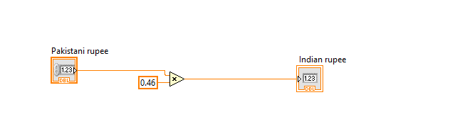

**OUTPUT:**

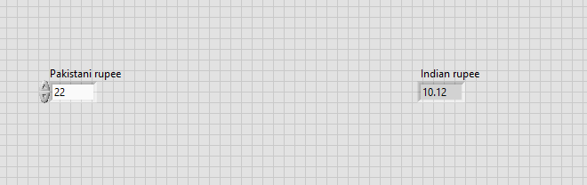

1. **From Pakistani Rupee to US DOLLAR**

**DESIGN:**

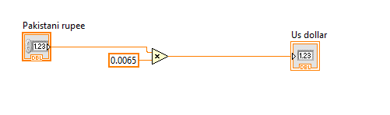

**OUTPUT:**

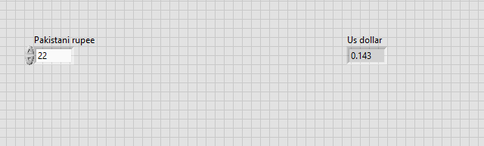

1. **From Pakistani Rupee to Chinese Yuan**

**DESIGN:**

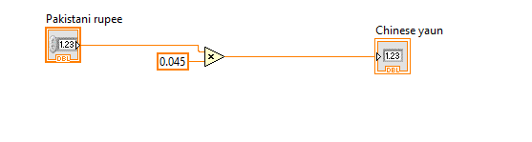

**OUTPUT:**

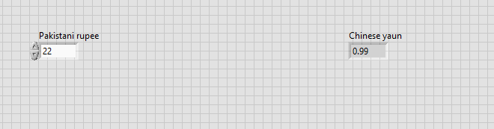

1. **From Pakistani Rupee to Saudi riyal**

**DESIGN:**

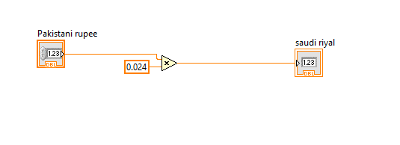

**OUTPUT:**

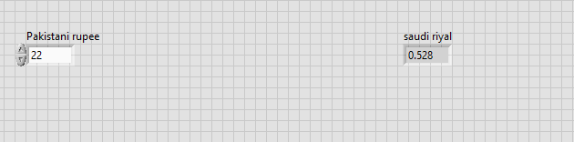

1. **From Pakistani Rupee to Iraqi Dinar**

**DESIGN:**

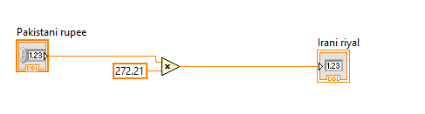

**OUTPUT:**

